Printed Documentation
Table Of Contents
TopForm® Contact Management 1
Contact Management 3
List Type 3
Contact Category Codes 5
Contact Source 6
Action Codes 7
Selection Codes 9
Contact Sales Representative Code 12
Standard Industry Code 13
Contact Setup 14
Contact Management 17
Contacts Main Tab 17
Codes Tab 18
Accessing your customer date from Contact Management 19
Status Tab 21
Operations Tab 22
Entering Notes 23
WordLink Tab 24
Action Code Setup 27
WordLink & Letter Writing 28
Creating Templates 29
Creating Profiles 31
List Profile 32
Using the Profile to Create Letters or Labels With WordLink 39
Using the Profile to Print Reports 40
Remove Call Detail Utility 42
Other Utilities 43

TopForm® Contact Management
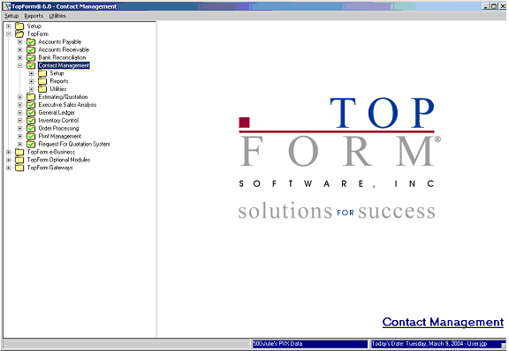

Introduction

The TopForm Contact Management module provides you with a vehicle to track notes and correspondence with your prospects and customers. It also integrates closely with your accounts receivable account master so that order history and product detail will be close at hand. As a result, your TopForm Accounts Receivable module should be implemented prior to setup of the Contact Management system.

This documentation is divided into two main sections:
- Getting Started
- Operations

Getting Started will outline the setup required before your Contact Management System can be used. Operations will cover the day-to-day use of the contact Management System.

Getting Started

Before you can effectively use your TopForm Contact Management system, you will need to setup the supporting codes that tailor the system to your needs.

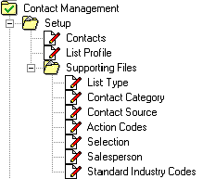

These codes can be found in the Supporting File folder contained within the Setup folder.
Among other things, these codes are used to filter through the entire database of contacts to create “profiles” for letter writing, reporting and call lists.

Contact Management

List Type
List Types segregate your contacts into separate lists. Although you may have some specific applications that would dictate the use of completely separate lists, please note that contacts can be sorted within lists very easily. Examples of different lists types would be:

- Prospects and Customers
- Vendors
- Collections

TopForm also uses the List Types to restrict access to prospects and customers by salesperson. If you wish to take advantage of this feature, you would set up one list type for “All” customers, and then one for each salesperson.

To setup List Types, simple choose this first folder from your Supporting Files folder. Enter in a List Type code up to four characters long. The system will respond with a dialog box asked you to confirm that you want to set up the new record. If the List Type already exists, it will display the description and the last number assigned.

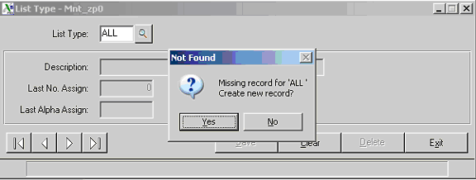

Click “Yes,” then fill in the description. In this case the description would be All Customers. You will also designate the starting contact code number, by entering the Last Number Assigned. In this case, we would leave this field set to zero. The first number assigned would be “1.”

If you have a million or more prospects and or customers within any given lists, you would use Alpha Contact Codes. Enter the last alpha code to assign as 000000. The first code automatically assigned would be 000001. After 000009 has been assigned, 00000A, then 00000B, etc.

Contact Category Codes
Although they could be used for a variety of purposes, Contact Category codes are generally used to categorize your contacts by industry specification. Below is a query that displays an example of contact categories.

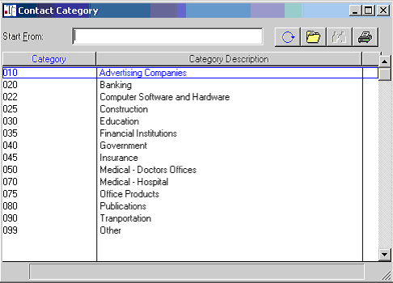

Contact Source
Contact Source codes are typically used to track the source of your prospects or contacts. You may want to track prospects that came to you as the result of specific advertising campaigns or as a result of client referrals.

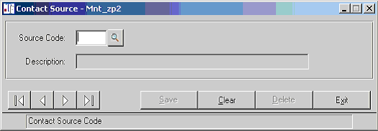

Action Codes
In addition to providing a filter for the purpose of sorting prospects, Action Codes, provide a “short hand” method of recording certain actions. In the example below “P” is short for Phone call.

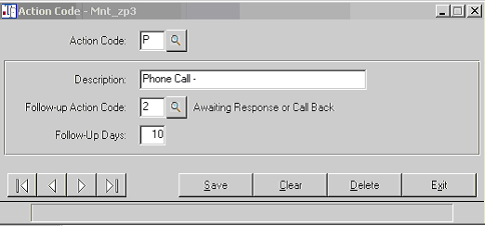

Enter the description of the Action Code, and then enter another action code to assign as the follow up code. You can also enter a default number of days for follow up.

Below is a listing of a few Action Codes from a sample query.

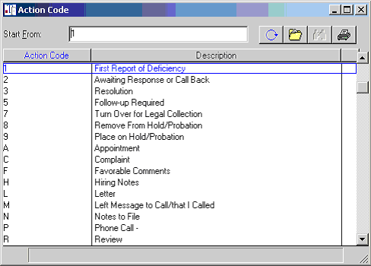

Selection Codes
Unlike the other codes discussed so far, Selection Codes are unique in that you can assign up to eleven selection codes per prospect. Use selection codes as additional “hooks” for filtering through your contact database.
Selection Codes to track Anniversaries - You might assign a selection code that identifies the anniversary of the month in which you started doing business with a specific customer. Use the Profile feature to automatically create letters to thank your customer for their business around the time of their anniversary.

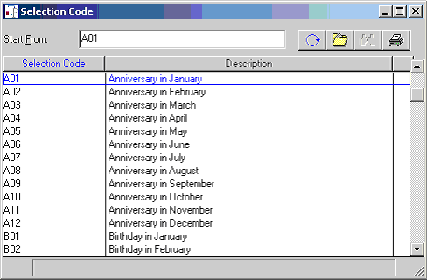

Selection Codes to track Collections – You may also want to use the Contact Management system to track your collection efforts. It provides for

- Immediate access to your customers real time receivables data
- Follow up dates and follow up actions
- Through TopForm WordLink you will be able to have standard collection letter templates to confirm agreements and/or promises made with regard to invoice payments.

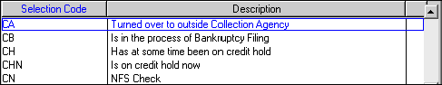

Selection Codes to track quality control - You may assign selections codes to specify certain actions or conditions with regard to quality control. As you can have multiple sections codes for each contact, one could be used to specify the type of complaint while another cross-referenced the vendor involved.

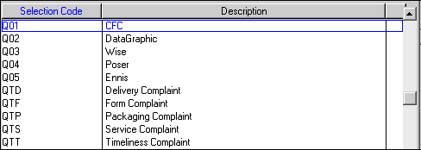

Selections code to track vendor performance – If you use the Contact Management System to track your vendor relationships, you can use Selections codes to provide a central database that contains that types of products each vendor offers as well the vendor performance ratings.

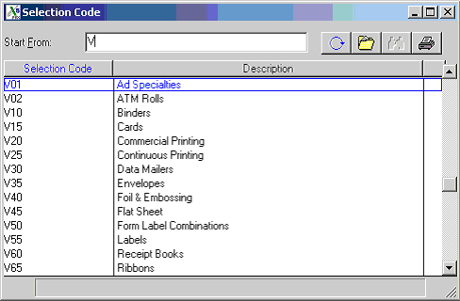

When setting up Selections Codes, you can restrict their use to certain List Types to which they are applicable. For instance, those selection codes that only related to Vendors, might be restricted to the VEN list, while those codes that are used only for collections might be restricted to the COL list.

Highlight a List Type and use the key to specify this List Type for the Selection Code.

Use to apply the Selection Code to all List Types.

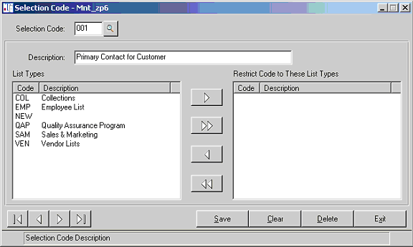

Contact Sales Representative Code
Enter the Salesperson code and the name of the salesperson. As the Contact Management System is integrated with Microsoft Word for letter writing purposes, also enter the title and the preferred letter closing.

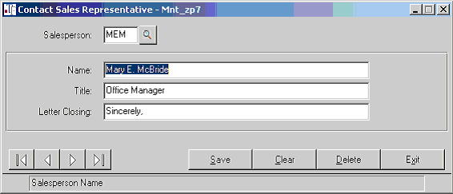

Standard Industry Code
In addition to the Contact Category Code, you can use the Standard Industry Codes for categorizing your customers and prospects into industry classifications.

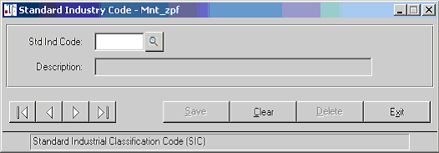

Contact Setup
Now you are ready to setup your contacts. Chose the “Contact” options from the Setup folder.

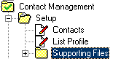

Enter the List Type and then click the Auto button to automatically assign the next contact button.

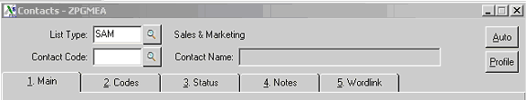

You will be prompted to enter an optional follow up comment, a barometer and the customer code. Normally, you would enter this information each time you initiate some contact with your prospect/customer, etc. However when setting up contacts for the first time, this dialog box provides you with a convenient method to record this information without navigating to the Notes tab.

You can bypass these fields by clicking “ok”.

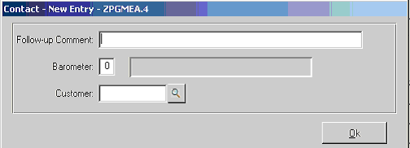

Enter the company name in the Contact Name field along with the other address and contact information. Note that following entering the street address field, you will be positioned in the Zip Code field, bypassing the City and the State. Enter a valid Zip Code. If you have used this Zip Code previously, TopForm will remember the City and the State. If information regarding this Zip Code has changed, you can edit the file that TopForm stores Zip Code information. Use the query button to view the Zip code data. Notice you will be positioned at the Zip code just entered. Then use the File Folder button within the query to access the Zip Code Setup Program.

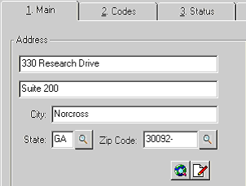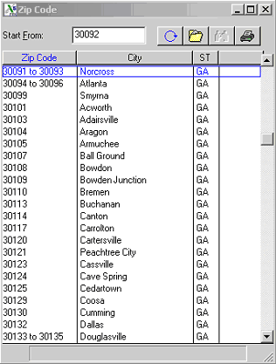

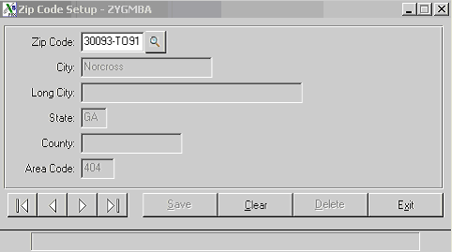

Use the Clear button, to clear the fields and enter the zip code information. Notice that there is a Long City field that is twenty-eight characters in length. If you enter a city that exceeds the original fourteen-character city field, the City name will be automatically stored here.

Contact Management

Contacts Main Tab
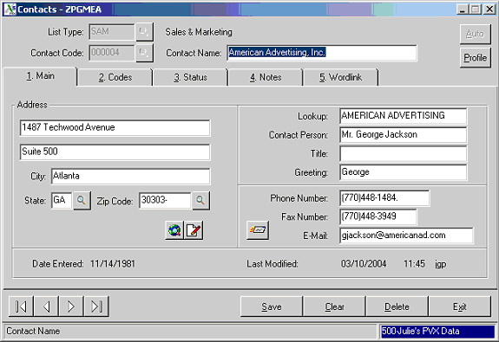

Lookup – Note that the first twenty characters of the company name will default in the Lookup field. This field is used for alphabetical searches. If you are entering an individuals name as the company name, for instance, Dr. Richard M. Smith, MD, you should probably change this default to SMITH, DR RICHARD to conform to standard alphabetizing rules.

Contact person – Enter the full name of the contact person, as this will be used for letter writing.
Title – Enter the title for the contact person.

Greeting – Enter the portion of the contact name that should follow the salutation (Dear) in a typical letter. This contact would be greeted as “Dear George:”

Phone, Fax and e-mail – Enter this additional contact information.

Codes Tab
On the Codes Setup tab, you can enter the Customer code from your Accounts Receivable system, the Salesperson code, the Source code, Category code and SIC code. Use the query button to look up these codes. If you have your contacts DUNS number, you can enter it here as well.

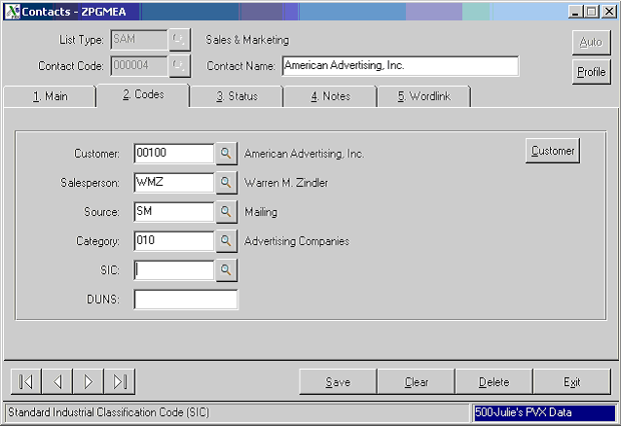

Customer - If there is a Customer code stored in the contact file, you will be able to click on the Customer button. This will take you to the contact’s customer file where you can view, among other thing, order history, open receivables, inventory, etc.

Accessing your customer date from Contact Management
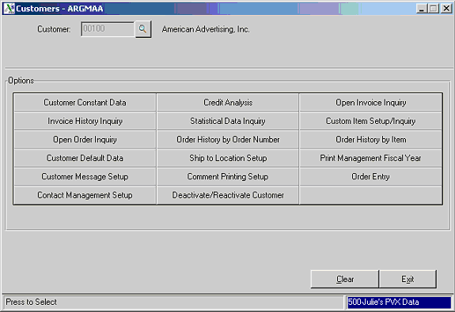

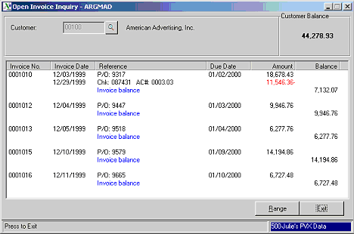

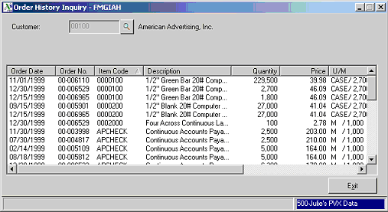

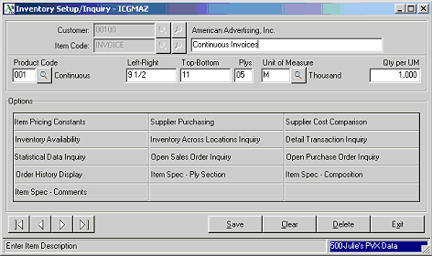

Depending upon your parameter settings, if you change the address information in the customer file, the changes will follow through to the contact file. These changes will not display until your refresh your screen.

Status Tab
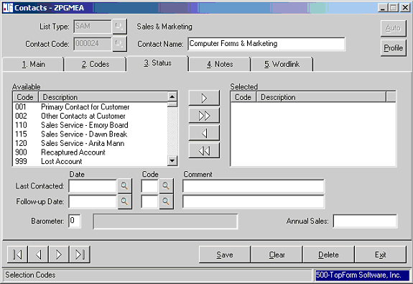

Selections Codes - On the Status tab, you can choose the Selection Codes from your list of available codes.

Last Contact Data - You can also enter Last Contact Date and Code. Based upon the setting in the Action Code Setup, the Comment, the Follow-up Date, Code and Comment will automatically display. This information will also automatically update from the notes that are entered on the Notes tab.

Barometer - The Barometer is a setting from zero to nine that indicates the relative interest level of the prospect. This field can also be used as a filter when performing a contact Profile.

Annual Sales - The Annual Sales field can be used the store the annual sales revenue of your prospect or could alternatively be used to store the potential annual sales revenue you might derive form this prospect.

Operations Tab
Now that you have completed the initial setup of your Contact Management System, you are ready for your daily operations. Daily operations could consist of the following:

- Setting up new Contacts and modifying existing contacts
- Entering Notes
- Creating Letters
- Creating Profiles
- Printing Reports

As part of your daily operations also includes setting up new codes and contacts. Please review the previous section for documentation on setup.

Entering Notes
The contact Notes Tab is used to record new notes and to view all previous notes entered for this contact. To initiate a new note, click on the “Add” button and enter the information.

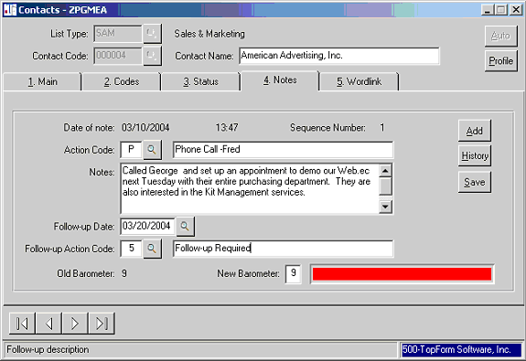

Action Code – Use your query button to chose the appropriate action code or enter the code if know. The Action description will display. You can override this description. In the example above, the operator added their name to the description that displayed.

Notes – Enter your notes. The notes will wrap when you reach the end of the line, however each note is limited to 164 characters total. If you need to enter additional notes, enter a new note record.

Follow-up Date – The Follow-up Date, the Follow-up Action Code will be defaulted based upon the entries in the Action Code file. Please note in the example below, the Action Code “P” has been set to default a Follow-up Action Code of “5” for follow-up in ten days.

WordLink Tab
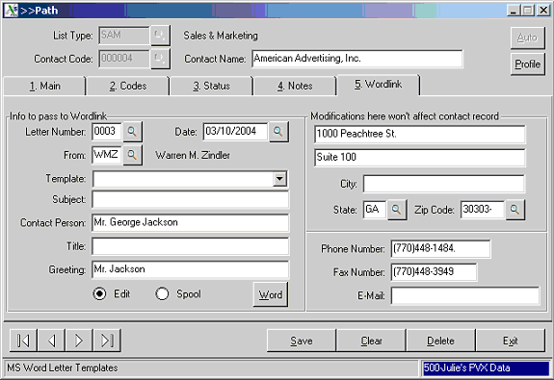

Your contact information has pre-populated the WordLink tab. These entries can be over written, for instance to send the letter to someone other than the main contact or to change the address for the letter. Each field will be discussed below.

Letters Number – Letters are set up in a queue. This above examples shows that this is the third letter in the queue.

Date – This will show as the date on the letter.

From – The closing on this letter will include the closing, the name and the title from the data contained in this Salesperson’s file.
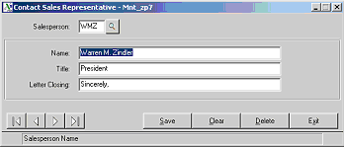

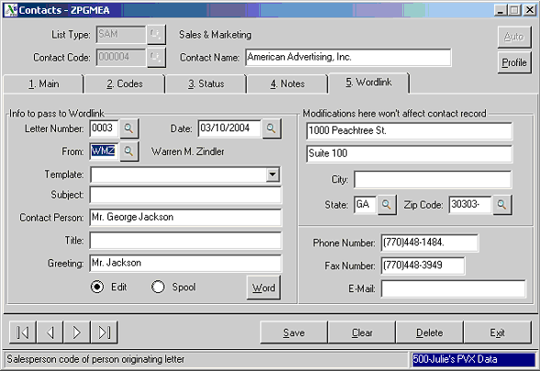

In the template drop down box you will be able to see the templates that you have created. Select the appropriate template and click on the “Word” button. This will bring up your letter in Microsoft Word and replace the mail merge fields with the data from your Contact.
The fields that are typically replaced are show below:

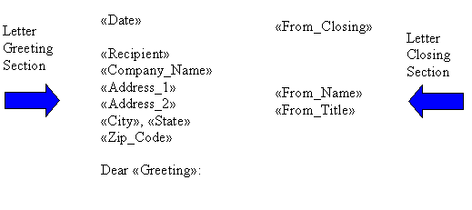

Action Code Setup
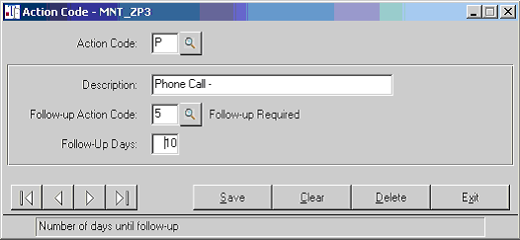

Barometer – Barometers are used to set the quality of the prospect. Zero is the lowest setting and nine is the highest. It too can be used to filter prospects for follow-up. This field displays the current setting. The Old Barometer field shows the current setting. The New Barometer field will update this setting. A graphic representation is shown next to the New Barometer.

WordLink & Letter Writing
WordLink is a TopForm program that integrates the TopForm Contact Management System with Microsoft Word. Using Word templates you can create letters on a one-up basis or as part of a mailing to a Profile. Upon selecting the WordLink tab for the first time, the following dialog box will appear.

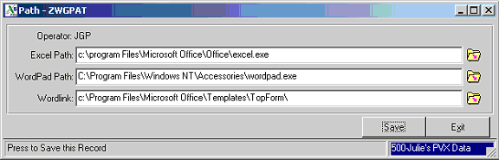

This sets the path for your Word templates. You can accept the defaults by clicking “Save” or override the defaults with your custom settings.

Creating Templates
WordLink is a TopForm program that integrates the TopForm Contact Management System with Microsoft Word. To use WordLink, for letter writing and envelope and label printing, you will need to set up your templates.
There are three steps in setting up templates:

Step 1 Create a new folder called TopForm in the following folder on your PC. This is a one-time setup for each PC. Save your templates as *.dot files in this folder.

C:\Program Files\Microsoft Office\Templates
Step 2 Create your letters in Microsoft Word.
Step 3 Use the mail merge features of Word and WordLink.

From “Tools” choose “Mail Merge”,

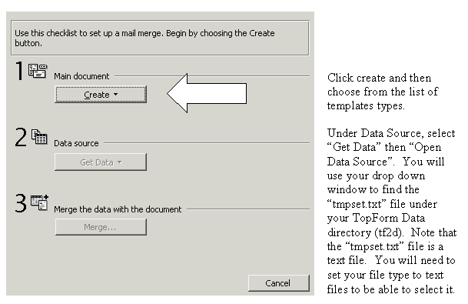

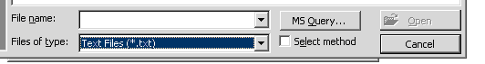

After selecting “tmpset.txt,” select “Edit Main Document.”

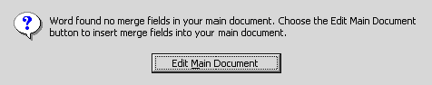

In the upper left corner of Microsoft Word you will see the option
“Insert Merge Field”.
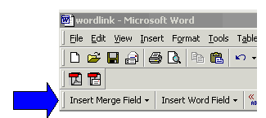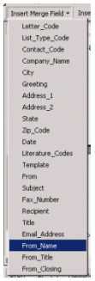

The list shown in the illustration to the right represents
the fields in Contact Management that are currently
available for mail merge. Select the fields you wish
to have merged into the current document.

After you have completed your template you will save
the document in TopForm folder created in Step 1.

You are now ready to use WordLink in Contact Management.

After creating a profile or selecting a contact, select your WordLink tab.

Creating Profiles
Creating Profiles

Profiles provide a means of filtering through all of your contacts to isolate a specific group for mailing or for telephone follow-up. Profiles can also be used to provide a call report, or for management to review call activity.
Multiple profiles can exist at the same time as they are user specific, that is, one user can create a profile. If another user logs in and executes the “Clear” option, and creates a new profile, the first users profile will remain in tact. There are two ways to access the profiling capabilities within TopForm. You can select the profile directly from the Contact Management Menu.

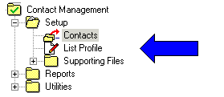

Or within the Contact file itself.

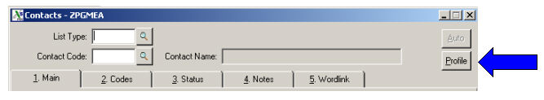

Upon clicking the “Profile” button from within the Contac file, the following dialog box will appear:

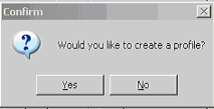

List Profile
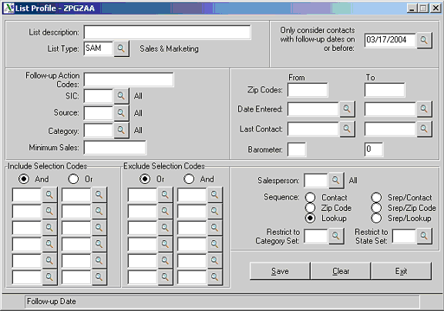

List Description – If you intend to print a report of the contacts isolated within a given profile, you can enter a description that will print at the top of the report to identify the nature of the profile.

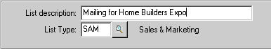

List Type – Enter the List Type to query for your profile. If you need to combine contacts from multiple List Types run the profile a second time. The qualifying contact form the second list will be appended to the first.

Follow-up Date – Only contacts with a follow-up date on or before the date entered here will be added to the profile.

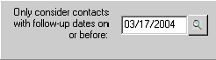

To review more details regarding each of the following codes, refer to the Getting Started section of this documentation.

Follow-up Action Codes – Enter up to sixteen follow up action codes or leave this field blank to include all Follow-up Actions Codes in the profile. The Follow-up Action Code is found on the Status Tab of your contact File.

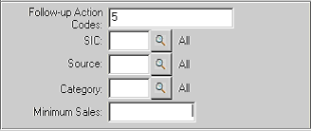

Note: If an entry is made in two or more of the following codes, it will assumed that the contact will need to meet both or all conditions to be included in the profile.

SIC – This stands for Standard Industry Code. Only contacts with this SIC code will be included in the profile. If this field is blank, all SIC codes will be included.

Source – Only Contacts with this Source Code will be included in the profile. If this field is blank, all Source codes will be included.

Category – Only Contacts with this Category Code will be included in the profile. If this field is blank, all Category codes will be included.

Minimum Sales – Only Contacts with an Annual Sales equal to or exceeding this value will be included in the profile. If this field is blank, all contacts will be included.

Selection Codes – Selection codes are unique in that your can enter multiple codes that cause a contact to be included, and/or excluded from the profile. If the contact must meet all the conditions of the Selections codes entered, click the “And” radial button. If, they need only to meet any one of the Selection codes, click the “Or” radial button.

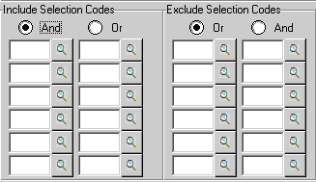

Range Logic for Profile Creation

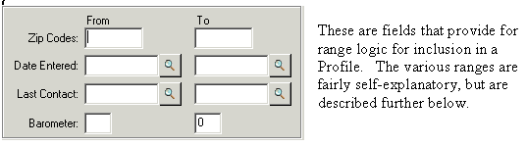

Zip Codes – Ranges of Zip Codes provide the option to create a profile of contacts within certain geographically areas. You might be calling on accounts and want to review of list of other contacts that might be conveniently located for a sales call. You may be planning a seminar in a city and want to send out invitations to other contacts within driving distance of the planned event.

Date Entered - range logic provides you with a list of contacts added to your database within a range of dates. You might want to acknowledge a new account with a “thank you” letter, or follow-up a request for information with an appropriate “second contact” marketing piece.

Last Contact – A sales rep can provide a call report by creating a profile of all calls within a date range. As a manager, you can view or print a list of all contacts for the week or the month organized by salesperson.

Barometers – Barometers of a low of zero to a high of nine can be assigned to grade the quality of the prospect. Perhaps your sales reps call on contacts with a Barometer of seven to nine and telemarketers call on Barometers three to six. You may choose to use an occasional direct mail piece for Barometers zero to two. Of course, these are only examples of how barometer range logic could be used to create profiles for certain actions.

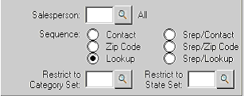

Salesperson – You can restrict the profile to only those contacts belonging to a specific salesperson.

Sequence – Use these radial buttons to specify the order in which you would like your profile to be organized. The choices are: by contact code, by zip code, or alphabetically by lookup code. You can also specify that they sort first by salesperson, then by contact code, by zip code or by lookup code.

Remember – with the exception of the Selection Codes where you have the “Or” option, if you have entries in multiple selection criteria, the contact would need to meet all the conditions to be included in the profile.

Upon completing your entries, you have the following options. The “Save” button, initiates the search of your database to create a profile of the contacts that meet the requirements that you have specified. The “Clear” button clears the “Profile” of any previous selections so that you can start over. The “Exit” button, exits the profile creation panel.

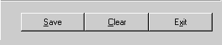

After clicking the “Save” button, you can make additional selections and click the Save button again to add additional contacts to your profile.

What can I do with my profile?

Profiles can be used to:
- View the entries one by one and take appropriate action on each
- Create Letters or mailing labels using WordLink
- Print Report

Telemarketing and/or Follow-up

If you entered the List Profile program directly from the contact file, upon exiting, you will be presented with the following dialog box:

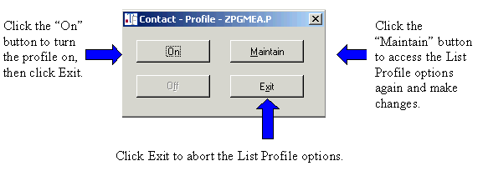

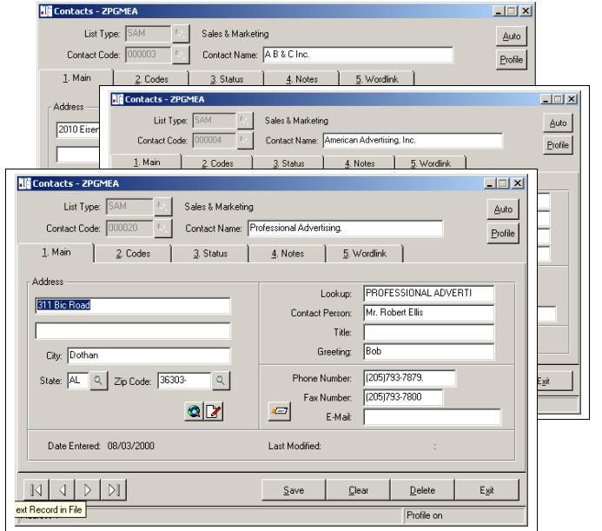

If you click the “On” button, you will be able to view each prospect in the profile with the use of the arrows located on the bottom right hand portion of your screen. The order depends upon the sequence you selected when creating the profile.

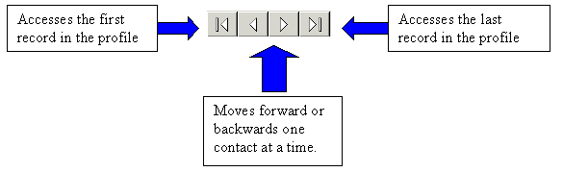

Using the Profile to Create Letters or Labels With WordLink
After turning the profile “On,” click on the WordLink Tab, click the “Clear” button to clear the panel of any contact information that may be active.

Date – Accept the defaulted date or enter a new date.

Template – From the drop down box, chose the template for your letter or your mailing label or both. For more detailed instructions on how to create a template, see the earlier section regarding WordLink and creating templates.

Subject – Enter an optional subject line. This can be one of your mail merge fields, or it can just update as part of the notes of your mailing.

Click the Word button. One letter and/or label for each of the contacts in your profile will be created.

Using the Profile to Print Reports

There are two Contact Management Reports. They can be found within the Reports Folder in the Contact Management System.

- The Contact Follow-up Report
- The Contact Masterfile Listing

Each of the Contact Management Reports can be printed for all or a range of contacts within or across List Types.

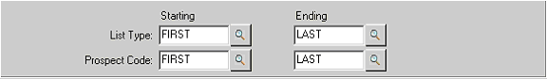

You can specify whether or not to print notes by checking the Print Notes box. If printing notes, you can limit the notes to only those subsequent to a certain date, or you can specify a minimum number of notes to print.

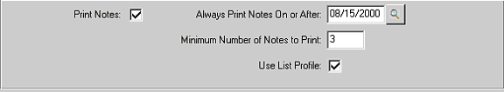

Both reports can also be restricted to only print the contacts contained within your profile.

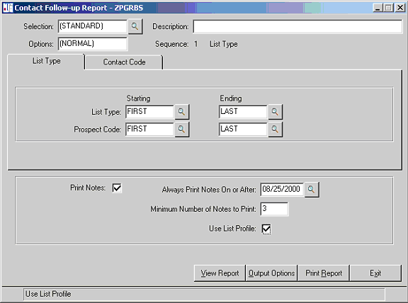

Remove Call Detail Utility
The notes that you enter for your contacts accumulate and are not automatically removed by the system. Although there usually isn’t any need to remove these notes, TopForm does provide a utility for this purpose.

This utility works in much the same way as the List Profile in that you can choose the notes to remove based upon a variety of options.

You should make a backup of your data prior to running this utility. Following the utility check the data carefully to make certain that you have removed only the notes that were intended. If you find that you have make an error in the selections, you could then restore your backup.

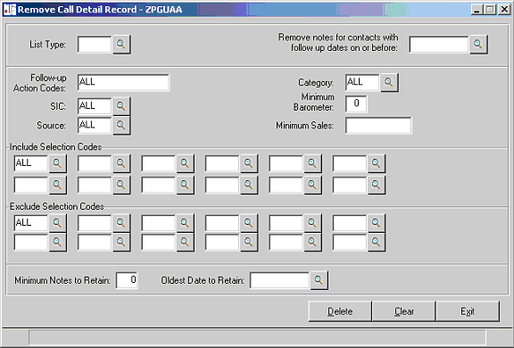

Other Utilities
There are other utilities available for performing file maintenance functions. Most often they are used in conjunction with data conversion to initially setup your Contact Management Sytem. Talk to your TopForm representative if you need assistance in performing any of the following:
- Copy Customers to Contact Management – This utility will create one contact record for each customer into one specified List Type.
- Change Contact List Type – This utility will process the current profile for the user and change the List Type to a new one. The contact code used for the new List will be based upon the next automatic number for that list. This utility is typically used to create multiple List Types from the single list created in the first utility. The first step would be to create the profile, usually for a single salesperson, and then change the List Type for all the customers belong to that salesperson. Repeat the process until you have created a List Type for each salesperson. Security by salesperson can then be initiated.
- Convert Prospects to Upper and Lower Case – This utility will process the Contact Management file and convert the data from all upper case to mixed upper and lower case. The following fields will be converted. The contact name, address lines one and two, the city, contact and greeting.
- Change Selection Codes – This utility program will process the current profile for the user and for each entry in the profile, change that selection code as specified.
- Contact Lookup Maintenance - This utility program allows you to step through the contact file and change the Contact’s alpha lookup field.
- Change / Move Contact Codes – This utility allows you to move a contact from one List to another. It also provides the option to copy a contact into a second List Type.
- Change Greeting Utility
- Rebuild Contact Sorts
- Rebuild Contact Note Sort
- Zero fill salesperson codes

